



Of
2015-2016



BUDDHA VIKLANG VIKAS SANSTHAN
(Registered Under societies registration act 21, 1860..)

Regd. office:-
Bhalua Road Domuhan, Bodh Gaya, Distt.- Gaya,
Pin-824231 (Bihar)

ANNUAL REPORT

ANNUAL REPORT
OF
BUDDHA VIKLANG VIKAS SANSTHAN
YEAR 2015-2016

Regd. office:-
Bhalua Road Domuhan, Bodh Gaya, Distt.- Gaya,
Pin-824231 (Bihar)

The executive committee takes pleasure in presenting the Annual Report of the SOCIETY named “BUDDHA VIKLANG VIKAS SANSTHAN” for the year 2015-2016. The aim, physical target, financial achievement, future planning etc. are as follows:
The executive committee has considered various project under consideration and decided to contract the various District State, National and International Departments and Agencies to fund for programs. There is not change in constitute of executive committee during the year under review.
The society has convinced in meeting of the executive committee during the financial year made successful, drive for the welfare of the poor, weaker, needy section including women and child. It has conducted many successful activities for the purpose for providing them technically efficient, improving their living structure and to empowering them to utilize the new opportunities. The SOCIETY is committed towards achieving economic and social empowerment of different caste, creed and faith.

ACTIVITIES & PROGRAMMES FOR THE YEAR OF 2009-2010

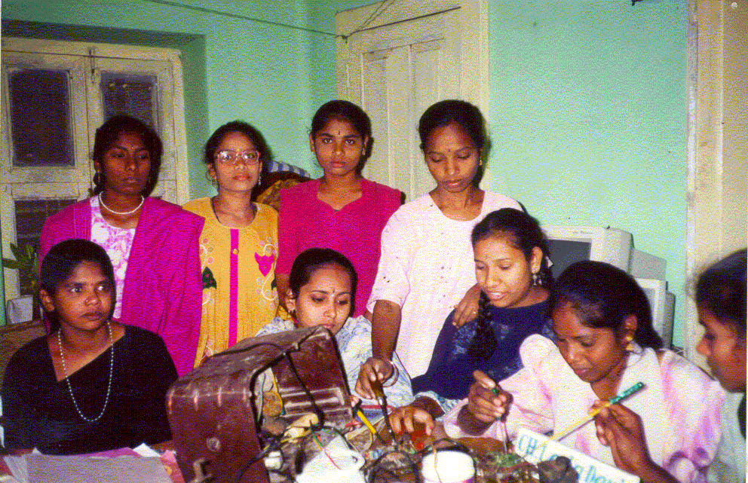
HANDICRAFTS TRAINING
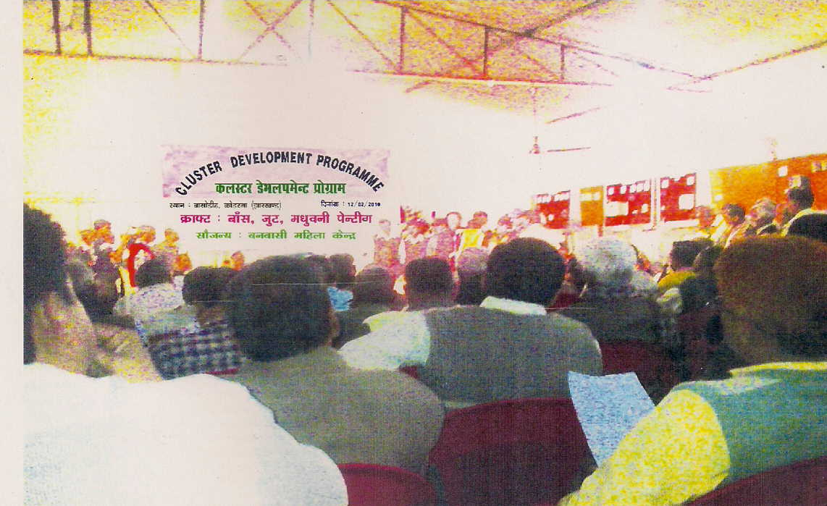
Our society organized handicrafts Training of traditional Indian handicrafts and home based products made by women who get vocational training in living of society from various to celebrate the festival season, during the period of Dushehara to Deepawali. The programme was organized in kodarama district under block Gaya of Bihar State. This handicrafts exhibition will showcase a wide collection of handicrafts and products including Maheshwari and Chanderi weaves, Tussar, Mirror work and Banaskantha, Jute and terracotta products, Chikan ki kadai, Papad-achar, and ayurvedic products. This programme is organized by our society for welfare of women workers belonging to the informal economy. Its twin goals are full employment and self-reliance. It is not just an organization but also a confluence of three movements- labour, women and cooperative.
The training was imparted to the community of society living under poverty line. The training was imparted as follows:-
- Process of Manufacturing
The manufacturing process involves following steps:-
1. Cutting and Stitching
Fabric as supplied by customer is measured for the exact requirement and placed on the table. Cutting portions are marked by a chalk an cutting is carried out by means of scissors. Stitching is carried out for individual portion of the garment and finally whole piece is made.

2. Checking and Pressing
Finally, the garment piece is checked before pressing on the checking table so that any fault in the piece may be removed. This individual pieces are pressed by using steam press in order to remove wrinkle marks. The pieces are kept ready for delivering to actual customers.
- Quality Control
As far as quality of products is concerned, care must be taken during cutting of the fabric to ensure the exact measurements that are taken while taking the orders. Customer's specification in respect of size, design and fashion are strictly kept in mind.

- Motive Power
Power requirement will be approximately 6 HP to run the unit.
- Pollution Control
Although not required, however, entrepreneurs have to contact State Pollution Control Board.
- Energy Conservation
Maximum care should be taken while selecting the machinery and other electrical equipments so as to maintain minimum power consumption.

NATIONAL ENVIRONMENT AWARENESS CAMPAIGN 2009-10
Our organisation conducted this programme to aware the society and encourage them to plant trees. Our organization successfully planted trees of various verities such as Amrapali, Maldah, Bombay, Kalkatia, in fruits and Neem, Jammun, Banana, litchi, Kathal and other more verities of public utility trees. The programme was held in Grant-in-Aid Assistance of Ministry of Enviroment and & forest through GVK, Gaya(Bihar). In this programme organisation's contribution was Rs.1,645 . The programme will aware the people as benefits of the plantation were described by our faculties in the meeting seminar. It will also help us in controlling the pollution problem, Sanitation problem, and other environment related problems.

ADOLESCENT DEVELOPMENT
Adolescent is a age of transition. In this age lot of physical, physiological and psychological changes associated with this age group and lack of knowledge and understand about these changes make them very vulnerable to all kind of reproductive health risk. There is a widespread ignorance and hesitation in imparting reproductive health knowledge, discussing these things in family, society and schools are thought to be tabooed subject. Even discussion on these things among adolescent are resistant and discouraged. But this tender age has intense urge to know about sex and sexuality and they resort to all kind of unauthentic source of information and it leads to misleading and wrong information regarding sex and sexuality and this situation makes them very vulnerable to all kind of sexual health problem.

We are working under this project on the subject of: -
To enhance the reproductive health knowledge of adolescent.
To inculcate responsible sexual health behaviour among adolescent.

Findings: -
- Increased knowledge about physical and physiological changes associated with adulthood.
- Have become receptive and knowledgeable on the issue of reproductive health.
- Have developed knowledge and importance of modem method of contraceptives for delaying first child.
- Have developed knowledge about STI/RTI and its prevention.
Imbibing safe sexual behaviours.

☺SURVEY & DOCUMENTATION☺
The base line survey with exhaustive questionnaire was conducted for child labour, reproductive & child health and aids awareness among the various people of district. Data for 1230 people were collected analysed and stored in informative way for future reference and uses.

NATIONAL FESTIVAL & OTHER IMPORTANT DAY CELEBRATION
OUR society time to time celebrate national festival & other importance day and also organized of seminar and conferences on various economic and social issues. The society regularly conveys its greetings to the people on important occasions like Republic Day, Independence Day, Deepawali, Environment Day, Women Day, Diabetes Day etc.

HIV/AIDS AWARENESS PROGRAMME
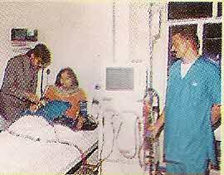
Our organisation conducted programme for HIV/AIDS awareness programme in which the participants were distributed condoms free of cost. this programme was for awareness of people on HIV/AIDS. India is sitting on an HIV/AIDS “time-bomb” and the epidemic could soon become like it in Africa unless immediate steps are taken to accelerate efforts to stem it. This is the warning from the head of an international survey agency. “The HIV/AIDS deadly disease in India is extremely grave. It is ticking time bomb. The epidemic is rising rapidly and could soon get out of control, unless the response was scaled up massively.”
The trajectory of the epidemic in India is the same as that in Africa and though the current level of the epidemic here may be 10 to 15 years behind that in Africa, it may not be long before it catches up. The catastrophic situation being faced in Botswana and other parts of Southern Africa “is just a vision of the future” that India could face. In BIHAR and Bihar, for instance, no one knows how many persons are affected.
OUR society accepted the need participating of community and social workers for minimize this problem. Without participating and involvement of the corporate sector, the NGOs and community-based organizations the Government would not be able to tackle the problem all by itself and more effectively in anti-AIDS programmes.
If people fear discrimination, they are likely to shy away from blood tests that are the only way to discover their HIV status. They will be reluctant to seek help and adopt preventive measures. All this increases the chances of the infection being passed on to others.
Our Government practices to awareness people about HIV/AIDS through print & tele media and own health care center, but not proper success to attain. Under the Action Plan the following areas will be covered.
- AIDS- The Invisible Inferno
- The Human Immunodeficiency Virus
- The Clinical Features
- Pediatric AIDS
- Pathology of AIDS
- Spectrum of Infections
- Cancers- The Added Agony
- AIDS-Related Complex (ARC)- An Early Clue
- Diagnostic Approach
- Treatment
- Prevention-Only Sure Cure.

☻FORMATION & TRAINING OF SHG☻
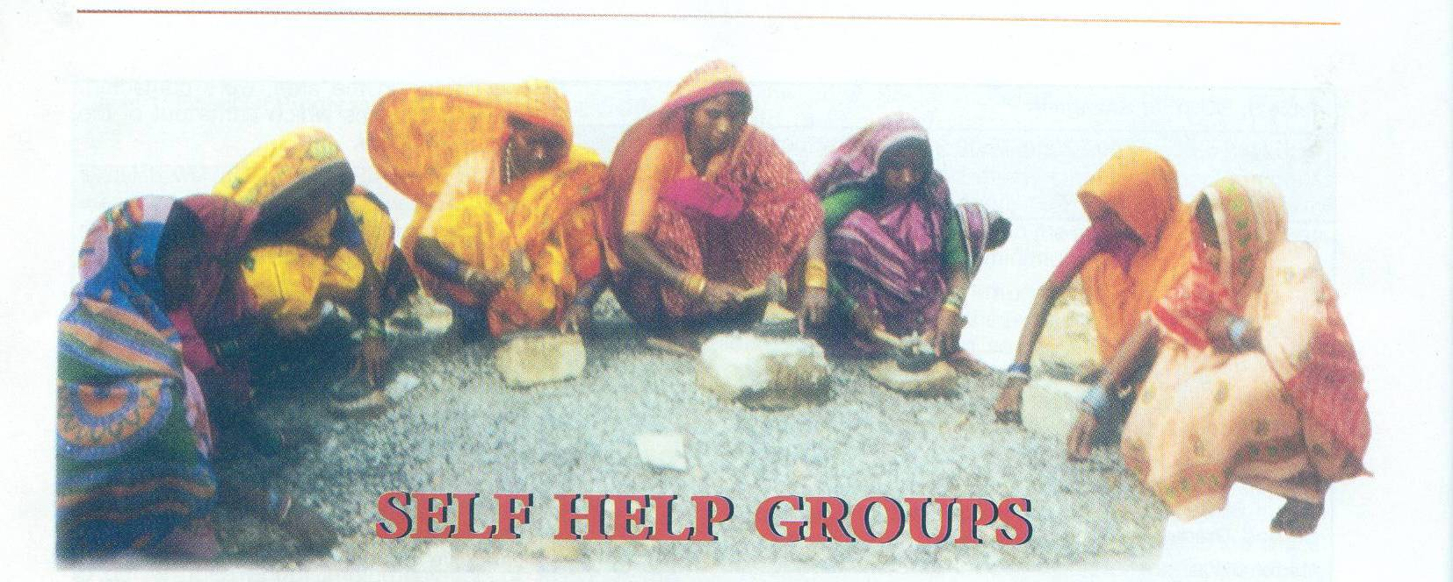
Self Help Groups (SHGs) enhance the equality of status of women as participants, decision makers and beneficiaries in the democratic, economic, social and cultural spheres of life. SHGs have an in-built mechanism where emphasis has been given over capacity building of women through developing their dialoguing skills. An SHG functions through its regular meeting, where members perform transactional activities and discuss over different related issues. This discussion among the group members is the means through which they give voice to their needs and it proves to be a platform for addressing their social and economic problems and enlightening their inner selves as well. The SHGs have inculcated a great confidence in the minds of rural women to succeed in their day-to-day life.
OUR Society is working for the formation and teaches about SHGs. According to Society SHGs is necessity for change economic and social standards of women. Society targeted one SHG formation each panchayats/ward. Under the Society observance 10 SHGs formed and running.

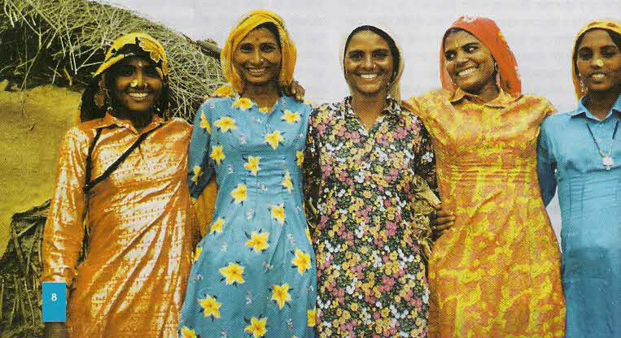
☻WOMEN EMPOWERMENT PROGRAMME☻
Women are being teased openly, molested mercilessly, stabbed ruthlessly, thrown out or running trains, burnt alive, attacked with acid, kidnapping and raped the list goes on impossible to tell apart. Self-protection gears up a woman to fight all this. Crime against women are growing by day, but most women still shy away from learning self-defence skills, they rather react negatively and see it as tomboyish and unladylike, or they think themselves too old for it, but according to society no age to teach self-defence and in view of present it is necessity of time.
In the beginning when advised to take up self-protection courses, most women react negatively, as they misunderstand the meaning of the term ‘self-protection’. But society realizes it is unfair to blame them for this because since childhood they have been conditioned to be physically non-aggressive and avoid hurting others. The most important aspects of self-protection are the awareness to recognize potential danger, avoid or neutralise any tense situation with assertiveness, verbal tactics, safety strategies and resorting to physical tactics as a last effort, which enables the would-be victim to effectively prevent, resist, escape and survive a close encounter.

AWARENESS GENERATION PROGRAMME
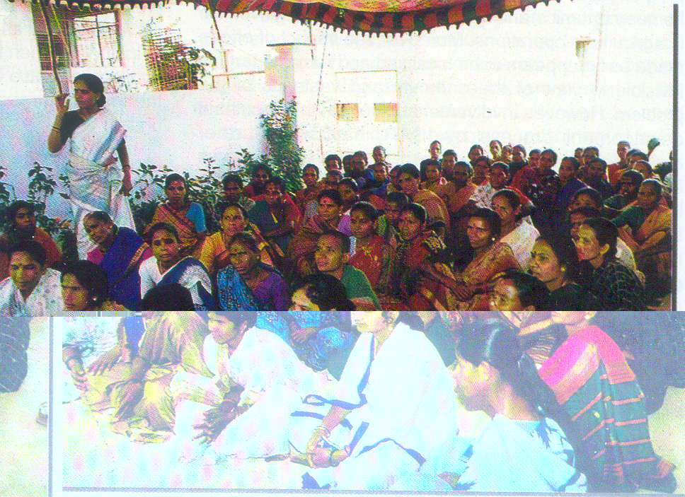
The celebration of World Women Day on 8 March, society organized a special programme on women, adopted, discussed and focused the major issue on Falling Sex ratio in India. According to a report the deficit of women in the population, which was three million in 1901, is now 36 million, the conference report notes, with the juvenile sex ratio at 927, according to the 2001 Census. In fact, the sex ratio for the population excluding persons from the Scheduled Castes is just 900.
A conference resolution calls upon the state to strictly implement laws against sex-determination and dowry, and to protect the girl child from discrimination. “Son-preference beliefs and rituals must be fought,” it states. According to the society assumed, women can play a central role on falling sex ratio using women in their public mobilizations.

EDUCATION PROGRAMME
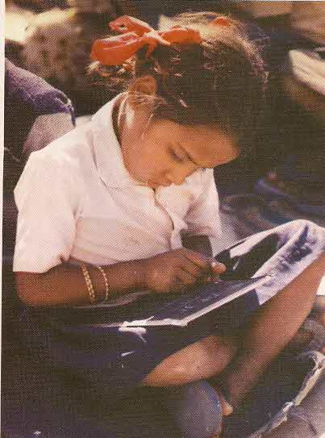
Modern system of education is very terrible. Burden of study and system of education made children old before age. Children's behave like a mentally sick. Sickness reason is demerits of education policy. So OUR society makes a special programme for child for teach and build up their persona. Where OUR society provide teaching with joke & mock. No burden of heavy bag of books and no tension of homework. About a research of UNESCO education for all programme have big stone is child labour also, remarks that India have positioned in twenty-nine country who not success to educate their people. Without solve economic problem we cannot success to increase standard of society and neither to nation.
In this programme you have main objectives opportunities for all. No differences of them they are girl or boy, poor or rich, and other basis. According to OUR society for children's proper development we have as well as possible arrange for their entertainment where they much laugh, much play, much sing and enjoy and teach them for help who are poor by them. It is our responsibility to teach every child they are not poorer than by other. If we are success to teach them than it is big achievement by us.

☻ROAD SAFETY PROGRAMME☻
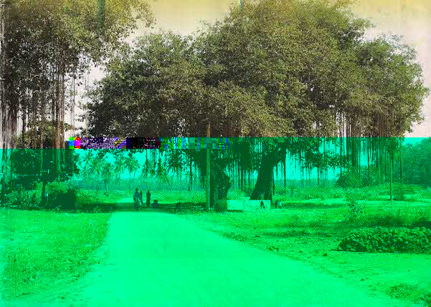
Day by day increasing accidental cases on the road it is big problems of the Govt., Society & People at a glance we can give answers in simple word reason is increasing rush of the traffic on the road. But according to society it is not facts of the cases of accidents. Many people don’t know the rules of traffic. Some people are only maintaining rules of traffic some are who they know rules of traffic but not maintain on the road. We have organized seminar and awareness camps on the above topic for the aware and teach the traffic rules.

 HEALTH & FAMILY WELFARE PROGRAMME 
The family welfare programme started by the society with the objective of reducing the birth rate to the extent necessary to stabilize the population at a level consistent with the requirements of the National Economy.
Society organised family welfare programme in many places of Bihar states. The literacy rate of the states are very low and the need of aware of the people fact that a small family is a healthy one. The effectively couple protected.
About this programme main view of the society is to provide family planning services within the broader context of maternal and child health care. It disseminates information and education to enable couples to make voluntary informed choices regarding size of the family and spacing through contraception.

CONSUMER AWARENESS PROGRAMME
Every individual, whether rich or poor, is a Consumer from the moment of his birth till his death, because we are constantly in need of “Goods and Products” on the one hand & “services” on the other for our daily sustenance. It is therefore but proper that all of us should become aware of our rights as a consumer of goods and services.
For long, the manufacturers and traders of goods and the providers of various services have been almost entirely motivated by consideration of maximizing their own profit, disregarding the interest of consumers. In fact, it is well known that the ordinary consumer is often exploited to such an extent that the market slogan was “buyers beware”. However, slowly but surely the scenario is changing, to enable the consumer to turn back and, now say “sellers beware”.
While Consumer Awareness on the one hand and the need for consumer satisfaction on the other is a fairly well accepted and established fact in most western and other developed countries, this is taking its roots in developing countries and more particularly in our own country only in the last few years.
One significant reason for the spread of consumer awareness in our country has been the enactment of unique Legislation, the Consumer Protection Act in December 1986. The preamble to the Act states that it is intended to provide better protection of the interest of consumer and for the speedy settlement of disputes.
It also goes on to add that it is intended to promote and protect certain specific rights of consumers. It will be as well for us to understand our basic rights as consumers, which the Consumer Protection Act proposes to promote and protect. These are: -
Right to safety i.e., protection against marketing of goods which are hazardous to life and property.
Right to Information about the quality, potency, purity standards and price of goods to protect the Consumer against unfair trade practices.
Right to be Heard i.e. to be assured those consumers’ interests will receive consideration at appropriate forums and at policy levels.
Right to Redress against unfair trade practice or unscrupulous exploitation of consumers as also to a fair settlement of their just claims and
Right to Consumer Education i.e. to acquire the skills and knowledge to be and informed and responsible consumer.
Obviously these are very wide ranging rights. The Consumer Protection Act seeks to promote and protect these rights by the establishment of Consumer Protection Councils at the Central and State Levels. Further, to provide speedy and simple redressal to consumer disputes, quasi-judicial bodies have been set up at the District, State and Central levels in the shape of District Forums, State Commissions and the National Commission for Consumer Dispute Redressal.
It is of course not enough that there is a law and there are remedies available. These have to be widely known over the length and breadth of our vast country so that Consumers at all levels and of all strata become aware of their rights under the law. They have also to know the procedures to be followed for getting redressal of their grievances and disputes. Here is where NGO’s in the area of consumer protection have an important role to play. In fact in order to provide better coordination and better implementation of the policies relating to Consumer Protection, there is a separate Department, the Department of Consumer Affairs. Most State Government has also set up such departments for dealing with consumer related matters at state level. Today there are over 800 consumer organizations all over the country, which are recognized by the central & state department of consumer affairs. Mostly these are registered societies, which are working on various types of consumer awareness programmes right up to the district and Panchayat levels. They advise consumers who have grievances as to how cases are to be filed in the District Forum and the State Commissions. Some of them even appear in the District Forum and the State Commissions to plead their cases. Some others even take on themselves the responsibility of resolving the disputes by taking up the grievances on behalf of consumers with the manufacturers, wholesalers or the retailers as the case may be. With increasing consumer awareness many reputed manufacturers and companies dealing with goods and products are paying more attention to the consumers and their viewpoints. In fact apex organisations like the Confederation of Indian Industries, Association or Chamber of Commerce etc. have Consumer Wings’ to deal with various aspects of consumer interests. However, we have still a long way to go in creating a much wider awareness that at present. Many consumer organizations are bringing out consumer related magazines both in English and Regional languages for creating awareness. Seminars and workshops are also held frequently for this purpose.

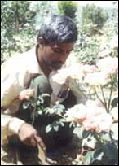
☻PLANTATION PROGRAMME☻
To stop illegal plant cutting and balancing environment our society started environment awareness programme. Under plantation programme our society working trees re-plantation for minimize bad effect due to pollution. Our society started free plant distribution of different kinds of plants in Gaya district. Our society also focused and working for to control sound pollution and water pollution. Our society tried to give massage in the people for planting in their birthday ceremony to celebrate.

POPULATION CONTROL PROGRAMME
One in six people in the world lives in India and the population may surpass that of China by 2040. Ironically, India was the first country to launch a national programme on population in 1952. The current issue coincides with The World Population Day on July 11. The war on poverty needs to be fought with the most modern equipment and involvement of all sections of the society, particularly the involvement of women. By channeling resources to reproductive healthcare, we can save lives and stabilize population growth and promote better living standards.
OUR society views the current population situation in India as serious, particularly in relation to poverty alleviation. The rising population has serious implications on food and water security, health care, rural and urban services and sustainability of the ecosystem. According to society if we have to pass on a world to the next generation, which is a much happier place to live in, then we have to with the War on Poverty. To control population growth our society organized meeting & seminars, population control awareness camps. Society teaches & advice people about “small family-happy family-strong nation” and get the knowledge them about new family planning programmes.
☻WELFARE PROGRAMME FOR SC/ST☻
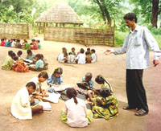
The project management committee of SOCIETY has been reported various cases related to SC/ST in the districts. The matter was discussed in the managing committee meeting. The matter was resolved positively to open and run to provide facilities to SC/ST. In several schemes including health, education was taken up among the SC/ST classes of people and we helped and we helped them avail of government aids etc. in this direction.

YOGA & NATUROPATHY PROGRAMME 4
Demonstration of yoga has been organized by the organization among School / College students and teacher Expertise Yoga and Naturopathy are available to the organization.
Yoga is the most ancient system of development of the body and the mind. It was practiced thousands of years ago in this country and is being carried out even today. Some say Lord Shiva was its innovator. Our ancestors practiced it with remarkable success to maintain good physic and to keep mind tranquil.
The eight steps of yoga or limbs (Astanga Yoga), according to Patanjali, are: Yama, niyama, asanas, pranayama, pratyahar, dharna, dhyan ana Samadhi. Yoga means control and discipline, niyama means rules, methods and principle, asanas relate to make physical postures, pranayama is kriyas with air, pratyahar is avoidin undesirable, dhyana is concentration, dhyana is meditation and samadhi is contemplation. Patanjali did not go into details about the eight types of yogas. Therefore more study or research was necessary. The results of further studies were that they were grouped under different categories according to nature: Bhakti yoga, Karma yoga, Jnan yoga and Hatha yoga.

Naturopathy is successful in curing many common and some chronic diseases. Nature cure is a comprehensive term applied to methods of natural forces and the defensive mechanism of the body. It is a distinct system of healing. It is not only very inexpensive and simple but also totally free of harmful side effects.
The nature itself is a healer since it has given us the capacity to fight and overcome diseases. The presence of germs in the human body is merely a symptom of a disease, not its cause. Many type of bacteria are present in the atmosphere but all persons do not fall victim to hem, because human body has capacity to ward off disease. A person falls sick only when his defences are down.
Naturopathy believes that the correct approach to eating is that a person should "eat to live" and not "live to eat". Eating should be a necessary function as breathing is, but most people regard it as a means of gratifying their desire for the nice things of life.
Our society organized these programmes with support of Local contribution, membership fees, donation and member’s contributions.

☻VOCATIONAL TRAINING PROGRAMME ☻
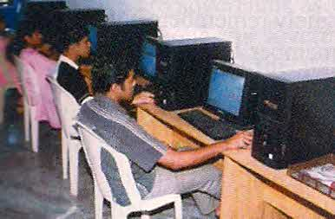
Unemployment is one of the scourges in the Project area and one of the greatest problems for the developing Societies project areas. The training was imparted to the poor people in different blocks of District of BIHAR State. Human beings are the means as well as the ends of production. So it should be borne in mind that they should neither be treated neither as only means nor as only ends. If there is no manpower planning, it is not possible for the country to get rid of frustration and consequently the rebellious tendencies are generated among the masses. For a democratic country unemployment is a blot, which cannot be washed off by all the welfare functions, which the Government might be performing. It will not be incorrect to say that the very institution of democracy becomes weak if the number of unemployed people abnormally increases in a country. Apart from it as manpower of a country is not fully utilized there are no chances of developing the economy of the country on the appropriate lines. The process of development necessitates the enlargement and the diversification of industries, which demands more manpower of various degrees and skills. Similarly education will have to be job-oriented. Since the supply of manpower cannot be decreased so proper planning in the public and the Private sectors should increase the demand for it. For India unemployment cannot be more disastrous than it can be in other countries.

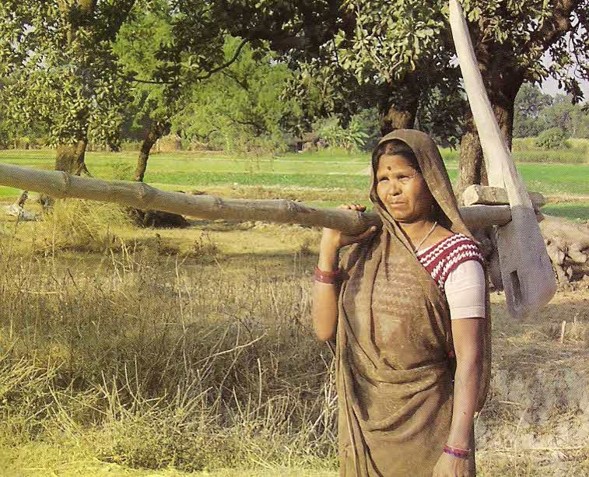
☻FARMER’S TRAINING PROGRAMME☻
Major population of India’s have depends on agriculture & related works. According to society farmers can make important role in growing Indian economy. They are faced some problems in farming. Main reason is their poorer farming technique.
OUR society organize a five days training to twenty farmers was organized in the village. In this training, farmers were trained to do farming by new and scientific methods. Where farmers get different guidelines to floriculture and nursery plants. To set up floriculture as an industry farmers get important guidelines. Also, given training how can make essential oils from use of different flowers such as jasmine, rose and tubes rose used in the manufacture. Experts from different agriculture universities were invited.

☻CULTURAL SHOW☻
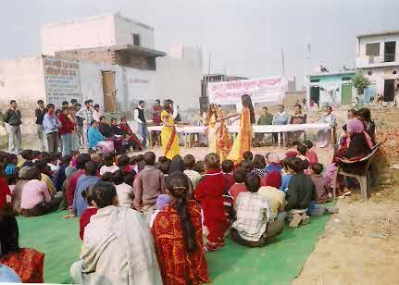
The kings and the courts all over the world have always patronized Art. Even in the present age it will not be possible to encourage artistic activities if the State does not take initiative, though democratic countries allow all types of activities, which do not interfere with law and order situation, to flourish. The policy of state control is necessary even if democracy stands for independence and freedom of the different social groups and the individuals. The preservation of culture, howsoever ancient it may be, is necessary otherwise the progress of the country will be in the wrong direction. In fact cultural activities reflect the prosperity of the project area. They not only serve as a diversion for the people but they are essential to preserve the national traditions. It is necessary to give direction to cultural activities otherwise there is a danger of reducing them to activities for monetary gains only. If the artists do not earn at least the subsistence wages, art may come to an end. Artistic activity is one of the most important human activities because it embraces not only the professional life but also the spiritual and aesthetic life of the individuals.

YOUTH AFFAIRS & SPORTS PROGRAMME
Our organization highlighted the conscious of youth towards the national integration and shape of the youth feelings. Because Youth has power to change the society. The organization organized vision development programme, and shared their ideas among youth. In this programme society organize a survey programme in the village for aware the people. Atrocities on women in this district are under wide survey. The society has deputed its voluntary workers for the identification and survey of women grass root causes of prostitution getting rise on. The comprehensive data are under evaluation during the year. The final analysis and report is expected to present in coming year.
Under this programme, a seminar on the topic ‘Science for all’ was conducted by the society. Over hundreds of people of the locality were participated in Programme had display the various practical aspect of science and technology in the field of agriculture and rural small-scale technologies. The Programme was over wheeling appreciated by the people. It was also emphasized to organize such programme in future also.

RURAL DEVELOPMENT PROGRAMMES
In rural housing programme, there is enormous scope for infusing the cost-effective construction technologies and building designs developed by institutions such as Nirmithi Kendras.
Most of the self-employment projects are “highly susceptible to obsolescence and face a high risk of rejection by consumers in favour of branded goods from the large scale industry”. In these projects, maximum scope for productivity enhancement through technology inputs is possible in the secondary and the tertiary sectors. The basic for building up this intervention should be through building forward and backward linkages leading to higher value addition.
The advances made in the space technology as well as information technology should be utilised for designing and monitoring watershed programmes.
With regard to the drinking water programme, S&T inputs are crucial to tackle the following problems:
Control of brackishness (reverse osmosis, electro dialysis with solid dissolvent).
Eradication of guinea worm (tube-wells, piped water supply, supply of filters).
Removal of excess iron (iron removal plants).
Control of excess fluoride (treatment methods like Nalgonda techniques, activated alum).
Tool kits and equipments supplied under Tool Kit programme were not very different from the locally available ones. Since they were not perceived to be more productive, the user population did not evince much interest in them.

Infusion of S&T into these programmes, if conceived and implemented in a need-based, beneficiary-oriented sustainable framework, would significantly raise productivity and quality of output, increase wealth-generation, create/upgrade durable assets and human resources with built-in capacity to adapt to changes.

☻ANIMAL WELFARE PROGRAMME☻
The organization BUDDHA VIKLANG VIKAS SANSTHAN organized an animal welfare programme in some districts of BIHAR. The Society called the specialist of veterinary science for welfare of animal in the programme. Now a days different kinds of diseases are found in the animals, that is out of symptoms, so it is must to checkup the animals by the veterinary doctors for their relief.
The people of various areas of Gaya district were present along with their animals for welfare of their animals. Welfare Programme was successfully conducted by the expert, specialist and experienced veterinary doctors. There were one hundred beneficiaries who directly benefitted from this programme and a number of people also indirectly benefited. Our society decided to conduct the same programme in future from time to time.

☻OTHER ACTIVITIES☻
Organization executed many other programmes and people got benefited in large scale. Some information have also been recorded from different localities for future use.

☻ACKNOWLEDGEMENT☻
Organisation acknowledge with gratitude to all those who have supported the organisation through contribution, donation and by different means directly or indirectly. Management Committee of the organisation places on record their appreciation of the encouragement and moral support from donors, members of the organisation, honorary persons and staffs associated with organisation along with community with whom organisation is working.

☻AUDITORS☻
Chartered Accountants, Gaya have conducted the audit for the year and are re-eligible to be re-appointed for next year.

The managing committee places on paper and its sincere thanks to the workers, members and beneficiaries for extension of co-operation and efforts.

For and on behalf of BUDDHA VIKLANG VIKAS SANSTHAN

(Secretary)

